**TITLE OF THE SYMPOSIUM**

M.R. Thefirst1, E.D Minutes2 and S.B. Last3

1Laboratory of physics, University of Real World, Place, Zip Code, City, Country

2Laboratory of chemistry, National University, Place, Zip Code, City, Country

3Laboratory of toxicology, Technical Research Center, Place, Zip Code, City, Country

Email: [thefirst@jesmile.zk](mailto:thefirst@jesmile.zk)

Key Words (5 max) :

A first general abstract should clearly introduce the content and organisation of the symposium **(<6,000 signs)**.

The theme and aims of the symposium should be described in one column **in WORD format** (like this example).

Use A4 page set-up and make all margins (top, bottom, left, right) 25 mm wide.

Start typing text here (about 7cm from the top of the page).

Use 10 pt Times New Roman font (except for the title which should be in 12 pt bold and in lower case).

Center the title, the authors’ names, the addresses and email address (corresponding author).

For the body of the abstract, start each paragraph with a tab, and use tab settings of 1 cm. Justify the body of the text both left and right.

Each communication composing the symposium should be next introduced with the title, the authors and their affiliations (like this example):

Title of the first communication, Author(s), Affiliation(s)

Title of the second communication, Author(s), Affiliation(s)

Title of the third communication, Author(s), Affiliation(s)

Title of the forth communication, Author(s), Affiliation(s) (optional)

Title of the fifth communication, Author(s), Affiliation(s) (optional)

**Each of those communications** should be detailed in an abstract following the model proposed in next pages of this document (one abstract per communication)

**THE FIRST CONTRIBUTION TO THE SYMPOSIUM**

M.R. Thefirst1, E.D Minutes2 and S.B. Last3

1Laboratory of physics, University of Real World, Place, Zip Code, City, Country

2Laboratory of chemistry, National University, Place, Zip Code, City, Country

3Laboratory of toxicology, Technical Research Center, Place, Zip Code, City, Country

Email: [thefirst@jesmile.zk](mailto:thefirst@jesmile.zk)

Key Words (5 max) :

The abstract **(<6,000 signs)** should be in one column **in WORD format** (like this example). Use A4 page set-up and make all margins (top, bottom, left, right) 25 mm wide. Start typing text here (about 7cm from the top of the page). Use 10 pt Times New Roman font (except for the title which should be in 12 pt bold and in lower case). Centre the title, the authors’ names, the addresses and email address (corresponding author). For the body of the abstract, start each paragraph with a tab, and use tab settings of 1 cm. Justify the body of the text both left and right.

Figures, tables and pictures may be included in the abstract, but make sure that they have a caption, and that they are numbered consecutively using Arabic numerals. The font used in captions should be 10 pt. Vertical lines in tables should be avoided. Figures should be in high resolution and in a form and of a quality suitable for printing. Examples of figure and table are shown below.

References should be written as examples shown below and cited in the text as “(Name *et al.,* Year)”. Leave a blank line above the list with references (and also above acknowledgement).

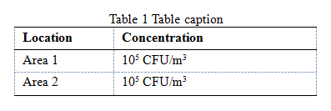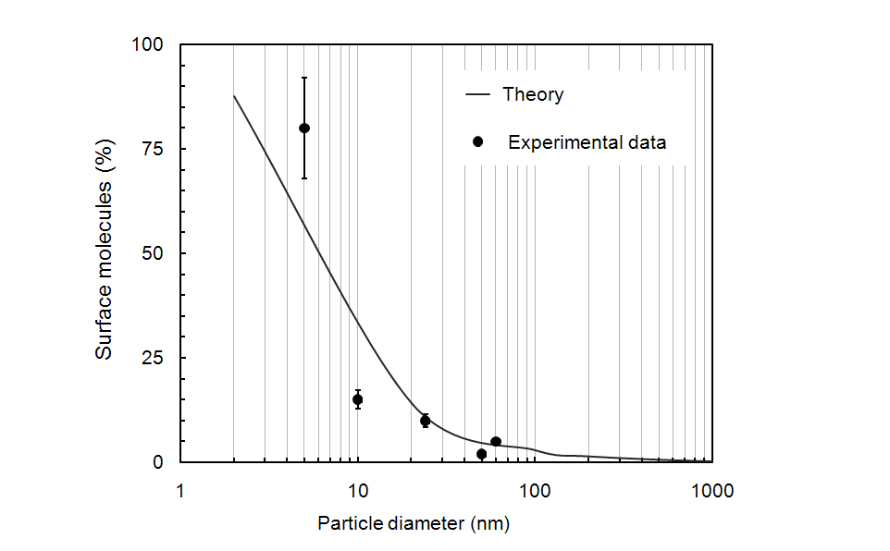

Figure 1. Figure illustrating good agreement between theory and experiment which includes experimental error.

The abstracts must be submitted in WORD format only on the dedicated platform.

The submission deadline for abstracts is **21 October 2024, for a symposium** and **18 November 2024, for an oral presentation or a poster**.

On the last page, authors should indicate the key topic, among those mentioned in the general information webpage. They should also indicate their preference in terms of oral, poster presentation, or symposium. The abstracts will be reviewed by the Scientific Committee. Abstracts which do not comply with the above standards will be rejected. Please avoid submitting abstracts containing only future results.

*Acknowledgement*: This work was supported by the National Health and Safety Council under grant A1/001.

*References*

Noise, D.B., & Sound, W.A.V. (2001). *Perspectives in Chemical Analysis – Principles, Techniques and Applications.* New York, USA: John Wiley and Sons, Inc.

Beep, S. (2010). *J. Toxicology and Aerosol*, 2, 1234-1243.